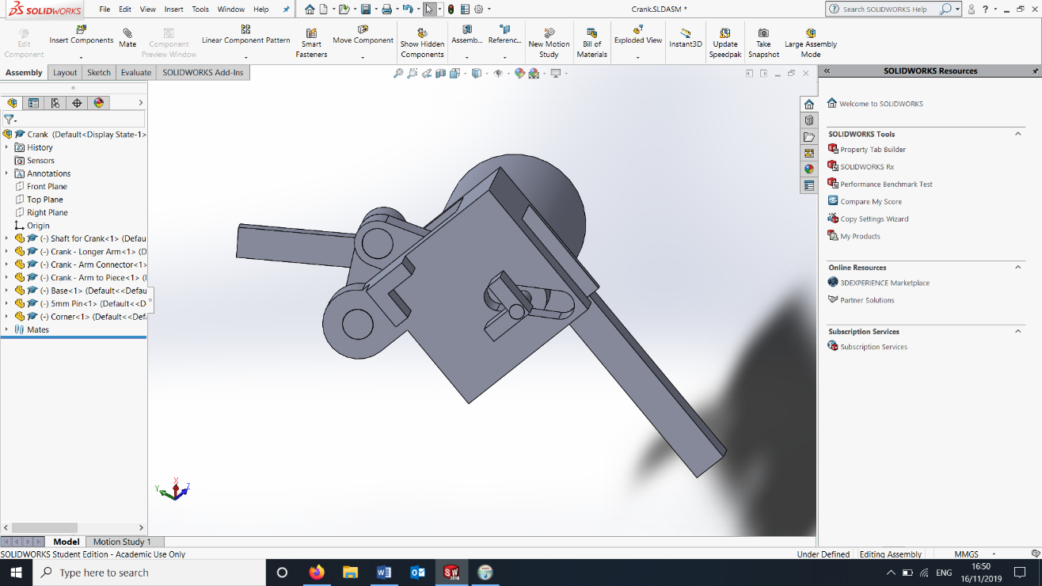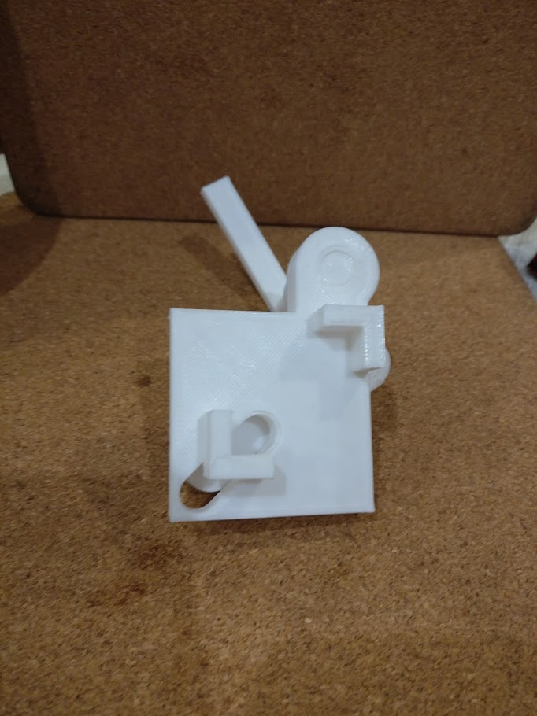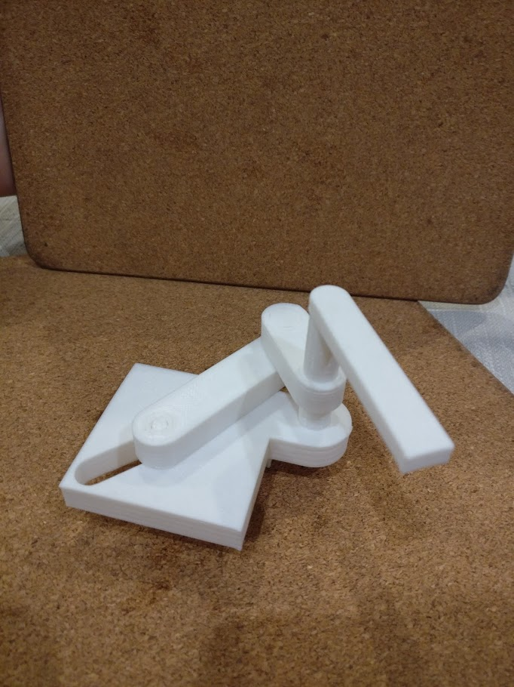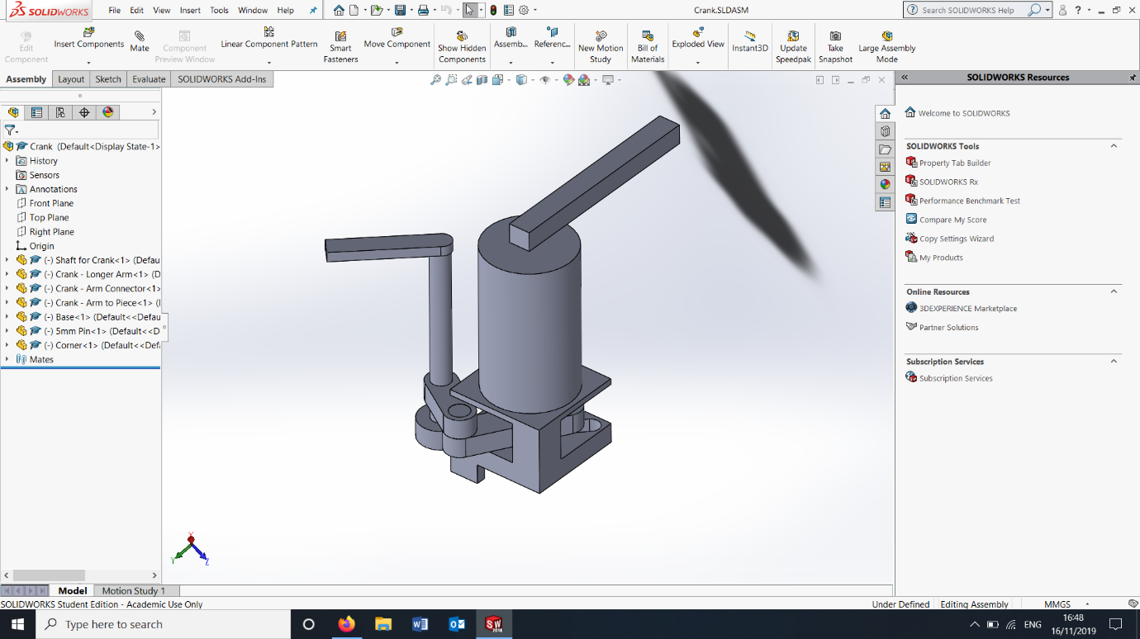

**Problem:**

*Design a mechanism which can be used to loosen and release the uppermost nut in a one inch ball valve which is used as a purge point in the pipe network.  This valve is situated underground in an inspection chamber [20 -30cm below ground] which has a variety of accessibility issues. The valve releases air from pipes.*

**Potential Solution:**

The part shown to the left would be used to secure the cap of the purge valve and adjust the size of the grip so that it could be used on different sizes of caps, the design was created through the use of the CAD package Solidworks.

When the arm to the right is rotated the crank arm moves shifting one half of the clamp either closer or further away from the other side to allow different sizes of caps to fit.

Once this is done the entire part can be rotated to allow the cap to be taken off through the use of the larger handle.

The drawback to this method is that a large moment will be created on each handle (in the up/down direction) and that could be enough to snap it off. A motor system or gear box could be designed which would allow the operation of this mechanism without the use of a long and potentially fragile handle.

The gearbox system would be harder to design and would be likely to seize up over time however would not require power like a motor system would and a similar system could be used as in wind turbines but in reverse – high speed to high torque.

The two pictures to the bottom show a 3D printed prototype of the adjustable cap mechanism, this proves that the mechanism works and is a feasible design.

Further Problems to be Solved:

* A mechanism to clamp the body of the valve.
* A method of avoiding a large handle to open the valve.

**Potential Design**